Visualization of output from Large-Scale Brain Simulations
Simon Benjaminssonª, David Silversteinª, Pawel Hermanª, Paul Melis^{b}, Vladimir Slavnić^{c}, Marko Spasojević^{c}, Kiril Alexiev^{d}, Anders Lansner^{a,}
ªDept of Computational Biology, CSC, KTH Royal institute of Technology
^{b}Visualization Group, SARA, Science Park 140, 1098 XG, Amsterdam, The Netherlands
^{c}Scientific Computing Laboratory, Institute of Physics Belgrade, University of Belgrade, Pregrevica 118, 1108, Belgrade, Serbia
^{d}Department of Mathematical Methods for Sensor Information Processing, Institute of Information and Communication Technologies, 25A Acad.G.Bonchev Str., Sofia 1113, Bulgaria

Abstract
This project concerned the development of tools for visualization of output from brain simulations performed on supercomputers. The project had two main parts: 1) creating visualizations using large-scale simulation output from existing neural simulation codes, and 2) making extensions to some of the existing codes to allow interactive runtime (in-situ) visualization. In 1) simulation data was converted to HDF5 format and split over multiple files. Visualization pipelines were created for different types of visualizations, e.g. voltage and calcium. In 2) by using the VisIt visualization application and its libsim library, simulation code was instrumented so that VisIt could access simulation data directly. The simulation code was instrumented and tested on different clusters where control of simulation was demonstrated and in-situ visualization of neural unit’s and population data was achieved.
Project ID: PRPC06
- Introduction
Today it is possible to simulate very large and also complex brain models on our supercomputers. The use of such simulations for integrating the massive amounts of experimental data from different sources and databases is critical for improving our mechanistic understanding of the functions of the normal and diseased brain and will likely increase dramatically in the near future. Efficient tools for neural simulation visualization are therefore clearly of interest to the larger computational neuroscience community. To visualize simulation output in a manner comparable to what can be obtained experimentally from neuronal as well as macroscopic measurements gives functional constraints on brain models, which are essential to validate them and for their use to make proper predictions and propose new critical experiments.

The aim of the project described here was be to develop an HPC workflow and software tools to allow visualization of output from such large-scale neural simulations and to generate animations of this. This should also be done in real-time by means of “in-situ” visualization, allowing control of and interaction with a neuronal network while the simulation is running. The simulations themselves were performed with the widely used NEURON simulator for biophysically detailed simulations and with a parallelizing simulator developed in-house called BrainCore for more abstract neuronal networks.

Our main interests have been to visualize changing properties of simulated neural systems and generate synthetic output. Important properties are neuron membrane potentials, spiking of neurons, and synaptic strengths between neurons or neural assemblies. More than one property may be of interest to visualize, either separately or simultaneously. Coordinates of neural elements could be generated from the simulation and may in some cases be changing over time, as e.g. in axonal growth. Photorealism has not been an aim. Neuron types could be visualized with different simple geometrical shapes, e.g. pyramidal cells could be shown as pyramids.

Synthetic “brain imaging” output could be voltage-sensitive dye (VSD), local field potentials (LFP), and magnetoencephalography (MEG) signals or other output from a simulation that can be directly related to experimental data. These are not necessarily located at a specific neuron location but are measured from a region of the brain or a local population of neurons. It could also be an output based on a specific measure of a simulated population, e.g. a synchrony measure of population activities or waves of activities. A user should be able to present the information in a specified geometrical way or mapped in a predefined geometry as specified from a model of a brain or a brain area, e.g. mapping simulated activity to a whole-brain wireframe model.

The work conducted was divided in three separate parts reflecting those slightly different aims and approaches, i.e. (i) insight visualization of intracellular potential and calcium levels of single neurons; (ii) visualization of a neuronal population activity measure (LFP), and (iii) in-situ (interactive real-time) visualization of network activity. These three parts are described separately below.

- Methods

  - Neuron data “insight” visualization

One type of visualization done on the simulation datasets are the so-called “insight visualizations”. These are meant to provide a visual reference of the underlying model’s behavior, to communicate scientific results, to check model correctness, etc. Important parts of this work were establishing useful mappings of simulation data to visual primitives and creating practical file layouts. For creating the insight visualizations we used ParaView 3.12 [1]. This is a widely used open-source scientific visualization package that provides flexible visualization functionality based on a pipeline model. It also provides parallel rendering, which is of interest for visualization of future large-scale brain models.

Specifications of the PC system used for producing the visualizations in this section are: Ubuntu Linux x86_64 system, Intel Core i7 @ 3.4 GHz, NVidia Geforce GTX 560 Ti. The system also had a 160 GByte solid-state disk, which most likely positively influenced the rendering performance, since reading data during rendering is a lot faster from a SSD than when using a conventional spinning hard-drive.

    - Model description

The model of a neocortical patch with neural spiking visualization was partially based on an attentional blink simulation done previously [1]. The simulation replicates the Rapid Visual Serial Presentation (RVSP) paradigm where visual items are presented in a serial stream and subjects are told to attend to particular items. The model consisted of two brain regions, a lower patch represents the parietal cortex and a higher patch represents the dorsal lateral prefrontal cortex (DLPFC). In total, the model had 55,296 neurons, divided evenly between the two regions. Each region is a patch of 4x4 hypercolumns, each containing 64 minicolumns. Each hypercolumn has 128 basket cells and each minicolumn has 5 layer-4 pyramidal cells and 20 layer-2/3 pyramidal cells. 64 orthogonal memory patterns are stored in each region as long-range connections between minicolumns. There are both feed-forward and feed-back projections between the regions which represent activity in the superior longitudinal fasciculus. This model does not have a visual cortex, so the parietal network is activated directly.

The network model was implemented such that it can be scaled to much larger sizes. It was successfully scaled up computationally on IBM Blue Gene supercomputers, although a 3D visualization of the output was not done at this time. The simulations ran for 1 second of cortical activity and stimulated a single memory pattern for attractor activation and pattern completion. On the Blue Gene/L at PDC, two cortical patches with feedforward projections similar to the visualized attentional blink model were scaled up to 32x32 hypercolumns with 128 minicolumns per hypercolumn. The model had 7 million neurons connected with 960 million synapses and executed on 2048 cores for 3 hours. On jugene, a Blue Gene/P at Julich, a single cortical patch was scaled up to 128x128 hypercolumns with 128 minicolumns per hypercolumn. This model had 57 million neurons connected with 7 billion synapses and executed on 16,384 cores for 3 hours and 20 minutes.

In the simulation protocol, a single unpotentiated memory pattern is stimulated at 100 ms into the simulation, for a duration of 60 ms. Following this starting at 1000 ms a sequence of 15 memory patterns are stimulated for 60 ms. Two of these are potentiated by 0.75 mV and the rest hyperpolarized by 0.75 mV. To activate a memory pattern in the parietal network, layer 4 pyramidal cells are stimulated in 5 of 16 minicolumns. This stimulation activates layer 2/3 pyramidals in those minicolumns, which are recurrently connected locally within the minicolumns and globally across hypercolumns of the region. If the activity is high enough, a pattern will complete across all minicolumns of the memory pattern. Active minicolumns within the parietal network also stimulate memory patterns within the DLPFC network, via the feedforward projections and provide pattern recurrence via the feedback projections. When an item in the RSVP stream is selected to be attended, the corresponding memory pattern in the DLPFC network is potentiated. If the attractor memory activation in the parietal network is high enough, a corresponding memory pattern will become active in the DLPFC as well, which in turn provides more recurrent activation in the parietal network. The model represents an attentional gate, so if a distributed memory pattern becomes active across both regions, this would represent awareness of a presented item.

To create the model neural coordinates, synapses and projections, a Matlab program was used to generate brain regions, hypercolmns, minicolumns, neuron coordinates, neuron rotations and inter-region projections. In each patch region, neurons were placed in space by generating planes for the minicolumns and basket cells. Minicolumn positions were placed randomly within hypercolumns, with a minimum distance. Basket cells were placed between these, with minimum distances between the minicolumn positions and themselves. At each minicolumn coordinate, pyramidal cells were placed at different z positions, separated by fixed distance. A small amount of noise was also added to the neural coordinates within the minicolumn. For each region, neuron numbers, types, coordinates and rotations were written to an ascii file, which was then converted to an HDF5 file (neurons.hdf5, see 2.1.2) with a python program. Feedforward projections were from single minicolumns to single minicolumns, between the corresponding memory patterns in each region. Feedback projections were from single minicolumns in the source region to the six closest minicolumns in the destination region.

The attentional blink simulations were run on 256 cores on an IBM Blue Gene/L, using the Parallel NEURON simulator. Within the Hodgkin-Huxley neurons, soma voltage membrane potentials and calcium concentrations were captured in 5 ms intervals. These were written out to files, which were also used for the visualizations. Each core was assigned two minicolumns, with one from the parietal region (lower patch) and one from the DLPFC region (upper patch). On each core, recorded output for soma membrane potentials or calcium concentrations was written to a separate ascii file in 5 ms intervals and included time, neuron number, neuron type and measured value. To convert this output to HDF5 files, several steps were needed. After all the individual core-specific files were concatenated together into one large file, the file was sorted first by simulation time and then by cell number. After this, A python program would step through each visualization time-step, read all neurons with measured values and write this out as a neuron-indexed vector in a single HDF5 file (volts.hdf5 or somaca.hdf5, see 2.1.2) for each time-step. This program was file-based, in order to avoid being memory bound and thus be able to scale to large network sizes. However, it was rather slow, since searching for each time-step was done serially. This can be greatly improved in the future by seeking forward in the file for each time-step a determinable number of fixed lines.

To visualize activity between regions, a projection activity file was generated, using another Matlab program. Projections between regions were originally generated from source and destination minicolumns. Spiking activity was also saved during simulations as events, with time and neuron number. So, to generate projection activity between regions, spiking activity was aggregated by minicolumn within a 50 ms sliding time window. If spikes occurred in a minicolumn within a current time window, activity was written out between active source minicolumns and destination minicolumns, based on the minicolumn to minicolumn projections. The format of the projection activity file was the activity timestep in 50 ms intervals, number of spikes in the source minicolumn and x,y,z coordinates of the source and destination minicolumns. The projection activity file was read in during visualization to show projection activity over a straight line. Future work can include replacing this line with a spline derived from diffusion tensor imaging of white-matter data between connected regions of interest. It might also include showing feedforward and feedback activity in different colors to show recurrent activity between regions.

    - Data organization

As described above, the simulation writes its output in a number of custom text-based file formats. These formats cannot be read directly by ParaView, so either the simulator code needed to be changed to write to a more appropriate file format, or the current output files needed to be converted in a post-processing step. The latter approach was chosen, since it involved less work. In future, the MPI-based simulator code might be augmented to directly produce data in the necessary file formats.

Simulation data was converted to Xdmf format ([3]), which uses a combination of storing large-scale data arrays in HDF5 files, while associated metadata is stored in a separate XML file. The Xdmf format can store datasets with different topologies (e.g. unstructured and structured grids and general geometric data). It allows per-element data attributes and has support for storing time series and hierarchical datasets. Most interestingly, ParaView has built-in support for reading Xdmf files. As mentioned, the actual simulation output was converted to HDF5 files, thereby providing efficient data containers that can fairly easily be read and written by custom tools, based on the HDF5 library.

A fairly straightforward data layout for the HDF5 files was used. As certain per-neuron values don't change over time, like position, we store them in a single HDF5 file called "neurons.hdf5", which has the following data layout:

HDF5 "neurons.hdf5" {
GROUP "/" {
DATASET "neurontype" {
DATATYPE H5T_STD_I8LE
DATASPACE SIMPLE { ( 55296, 1 ) / ( 55296, 1 ) }
}
DATASET "position" {
DATATYPE H5T_IEEE_F32LE
DATASPACE SIMPLE { ( 55296, 3 ) / ( 55296, 3 ) }
}
DATASET "rotation" {
DATATYPE H5T_IEEE_F32LE
DATASPACE SIMPLE { ( 55296, 3 ) / ( 55296, 3 ) }
}
}
}

As can be seen each neuron has a fixed 3D position and orientation (expressed as a rotation from a base orientation). Different types of neurons are distinguished by single integer type field (1 = layer 4 pyramidal, 2 = layer 2/3 pyramidal, 3 = basket).

The time-varying model data was stored in separate HDF5 files, one for each timestep, containing the voltages for all the neurons:

HDF5 "volts_0000ms.hdf5" {
GROUP "/" {
ATTRIBUTE "measurement" {
DATATYPE H5T_STRING {
STRSIZE 4;
STRPAD H5T_STR_NULLPAD;
CSET H5T_CSET_ASCII;
CTYPE H5T_C_S1;
}
DATASPACE SCALAR
}
ATTRIBUTE "microsec" {
DATATYPE H5T_STD_I32LE
DATASPACE SCALAR
}
DATASET "voltage" {
DATATYPE H5T_IEEE_F32LE
DATASPACE SIMPLE { ( 55296, 1 ) / ( 55296, 1 ) }
}
}
}

Time-varying calcium concentrations were stored using a similar layout.

Spiking neurons were detected by processing the voltage series and thresholding the voltage values. In general, there are far fewer spikes than there are timesteps. The spikes were stored as a simple position/rotation pair, allowing spikes to be highlighted by placing a visual marker in the relevant position:

HDF5 "spikes_0080ms.hdf5" {
GROUP "/" {
DATASET "spike_positions" {
DATATYPE H5T_IEEE_F32LE
DATASPACE SIMPLE { ( 1, 3 ) / ( 1, 3 ) }
DATA {
(0,0): 0.00127422, 0.000228367, 0.00115082
}
}
DATASET "spike_rotations" {
DATATYPE H5T_IEEE_F32LE
DATASPACE SIMPLE { ( 1, 3 ) / ( 1, 3 ) }
DATA {
(0,0): -0.240513, -0.260281, -0.0988702
}
}
}
}

A small number of Xdmf files were created that combined a series of per-timestep HDF5 files with the fixed attributes in the neuron data file.

    - Visualizations

Abstract visualizations of the simulation data were produced, based on the Xdmf datasets described in the previous section. The neurons themselves were visualized using “glyphs” – small abstract visual elements placed at the neuron positions. Here, we chose simple points, each a few pixels wide. The glyphs are colored by membrane potential (voltage in millivolts). For spiking neurons, whose voltage exceeds a certain threshold, larger cone-shaped glyphs are shown. These cones are also oriented based on the neuron rotation values.

Projections

Activity over the forward projections between the two areas of neurons was visualized by animating a series of glyphs between the sending and receiving minicolumns. For each projection event a varying number of potential spikes travel between the minicolumns in a 50 ms interval. Each spike is represented by a sphere glyph, its size relative to the number of spikes in the interval. In
Figure 1, one frame of the visualization is shown, 140 ms into the lag5 simulation. Also visible are the oriented spiking glyphs, colored by soma membranevoltage potential.

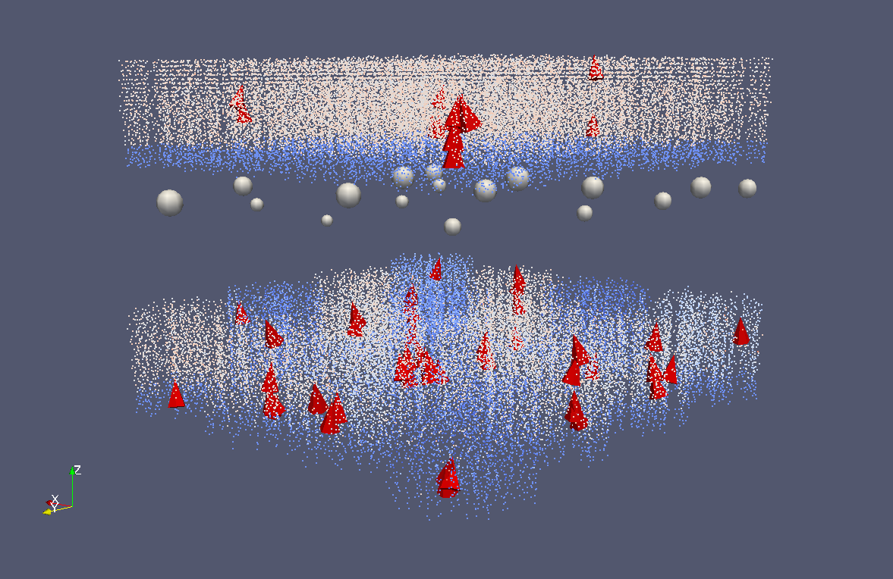

Figure 1

Wireframe brain

A wireframe model of a brain was added to provide some spatial context for the simulation model (Figure 2). The basis for this model was a publicly available MRI dataset, from which an isosurface was extracted, followed by decimating the resulting mesh.

The placement of the simulation model within the brain is currently done visually, based on the average location of the parietal cortex within the brain. In future, proper placement based on e.g. Talairach coordinates might be used.

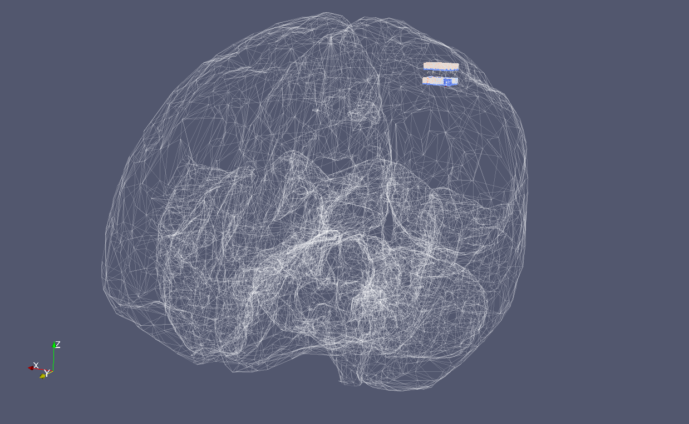

Figure 2

Calcium imaging

A separate variant of the above visualisations was made for the case of calcium imaging. Instead of membrane potentials, per-neuron soma calcium soma concentrations were produced by the simulation. The visualization pipeline used for calcium imaging largely corresponds to the pipeline used for the membrane potential visualizations. Small changes were the use of grey-to-white color mapping of calcium concentrations and the use of a black background. This color scheme matches real-life calcium imaging results.
Figure 3

Figure 3

  - In-situ visualization of neural dynamics

Today’s scientific simulations are often distributed over many thousands of cores,producing large amounts of data which are written to hard disks. As the access time of disk drives is several orders of magnitude higher than CPU-to-memory access, writing results to disk files creates a major performance bottleneck. Common usage of visualization tools imply that users import their data via disk files, making data visualization and analysis a post-processing step. In-situ visualization addresses this problem by giving users an opportunity to visualize their data while the simulation is running, by gaining direct access to the memory pointers of the simulation code and providing the ability to steer the execution of the simulation (stop, reset, continue to run). In addition to this approach, visualization of the data uses the same level of resources that are being used for data generation. Usually, visualization receives fewer processing resources, typically only a local computer.

VisIt [4] is a free, open source, platform independent, distributed, parallel tool for visualizing and analyzing large scale simulated and experimental data sets. Target use cases include data exploration, comparative analysis, visual debugging, quantitative analysis, and presentation graphics. VisIt employs a distributed and parallel architecture in order to handle extremely large data sets interactively. An important additional feature is its in-situ approach which is provided by its libsim library, which allows the visualization of simulation data in situ, thus avoiding the high costs of I/O associated with first writing and then reading the same data again (Figure 4). The libsim simulation instrumentation library can be inserted into a simulation program to make the simulation act in many ways like a VisIt compute engine (component that reads the data and performs most of VisIt’s processing). This library, coupled with some additional data access code that has to be written by the user and built into the simulation, gives to VisIt’s data processing routines access to the simulation’s calculated data without the need for the simulation to write files to a disk. The libsim library is responsible for listening to incoming VisIt connections, connecting to them, dynamically loading the runtime that allows the simulation to act as a VisIt compute engine, and responding to console user input or input from VisIt. An instrumented simulation may begin its processing while periodically listening for connections from an instance of VisIt using libsim. When libsim detects that VisIt wants to connect to the simulation to visualize its data, libsim loads its dynamic runtime library that contains the VisIt compute engine’s data processing functions. Once the runtime is loaded, simulation connects back to VisIt’s Viewer and requests for plots and data can be made as though the simulation was a regular VisIt compute engine. When a request for data comes in from VisIt’s Viewer, the simulation is asked to provide data via some data access code. A data access code consists of a set of callback functions that the simulation must provide in order to serve data to VisIt. The data access code is written in the same language as the simulation program and acts as a connector that allows the runtime to access the simulation’s data.

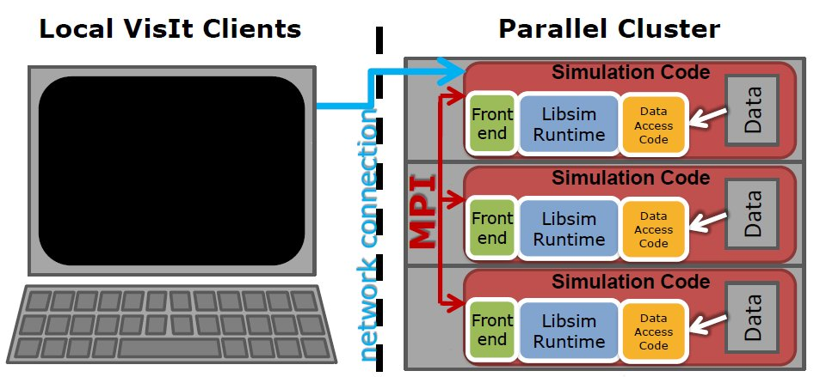
Figure 4. Getting data to VisIt from an instrumented parallel simulation (taken from Ref. [5]).
In order to make in-situ visualization of the simulation possible, several important steps must be performed:
- Making a VisIt installation that can run in parallel available on target execution systems, usually by compiling it from the source.
- Instrumenting the simulation code:
  - Performing the libsim initialization
  - Altering the simulation’s main iterative loop to listen for connections from VisIt
  - Creating data access callback functions so that simulation can share data with libsim
  - Adding control functions that let VisIt steer the simulation
- Building a simulation code and linking it against the libsim library
- Running a simulation on the target system in a standard way as for the regular non-instrumented version (usually through the cluster’s batch system)
- Connecting to the simulation from the remote work station with the VisIt installed (it could be a precompiled version obtained from the VisIt web site but it has to match the VisIt version deployed at the execution cluster)
- Performing simulation steering and visualization of live simulation data
.
The main steps for in-situ visualization of the simplified BrainCore simulation code (provided by KTH) using VisIt are described in the following subsections. We used VisIt 2.4.0, the latest version available, and our main source of documentation was provided by Brad Whitlock [6].

    - Instrumenting the BrainCore code

The BrainCore code is object-oriented C++ code for neural simulations which uses the Message Passing Interface (MPI) for parallelization. It has been shown to have good scaling properties up to hundred thousands of cores [7]. The main part of the code base is a library that implements the simulation and provides ability for a user to configure the network and simulation process. The remaining part consists of examples of using the network library in which simple network structures and simulations are defined. We used one example network for libsim instrumentation.

We performed the initialization of the VisIt environment in the main() function and in the constructor of the class NetworkDemoVis which is derived from the Network class. Changes in the main()function included adding the VisIt initialization function VisItSetupEnvironment() and changes in the constructor included registering the callback functions for global communication:

VisItSetBroadcastIntFunction(visit_broadcast_int_callback); VisItSetBroadcastStringFunction(visit_broadcast_string_callback);

calling functions that set libsim to operate in parallel and set the rank of the current process within its MPI communicator:

VisItSetParallel(sim.par_size > 1);
VisItSetParallelRank(sim.par_rank);

and finally adding the function VisItInitializeSocketAndDumpSimFile(), that will be executed only by the process with rank 0 and which makes simulation start listening for inbound VisIt socket connections and writes a .sim2 file that tells VisIt client how to connect to the simulation.

We added the simulation_data type field to the class NetworkDemoVis. This is a structure which consists of fields that represent the simulation state (process rank, the number of processes, simulation cycle…). NetworkRun() method, the member of the example NetworkDemoVis class, redefines the virtual method in the base class Network. This method was used as a simulation mainloop function (typical libsim in-situ approach), where all interactions with VisIt were defined and through which single steps of simulation were called (Simulate() method of Network class). Function VisItDetectInput() was added to detect the VisIt client input from the listen socket and switch block in which different actions were defined, depending on the output of the VisItDetectInput()function: To continue with the simulation (simulate one step) if there is no VisIt input, to try to successfully connect to VisIt if that kind of attempt was detected, to respond to VisIt’s request to perform a particular compute engine command, and finally to detect an error in VisIt interaction. It is important to say that only the root MPI process (with rank 0) performs execution of VisItDetectInput() function and it broadcasts its output to all other MPI instances. In case of successful connection with remote VisIt client, functions that forward metadata to client and perform registering of functions for accessing the mesh and variables data are executed:

VisItSetCommandCallback(ControlCommandCallback, (void*)sim);
VisItSetSlaveProcessCallback(SlaveProcessCallback);
VisItSetGetMetaData(SimGetMetaData, (void*)sim);
VisItSetGetMesh(SimGetMesh,(void*)sim);
VisItSetGetVariable(SimGetVariable, (void*)sim);

The first function registers the ControlCommandCallback() function, which allows steering of the simulation through VisIt simulations window and Commands buttons from the Controls tab (like stopping the simulation, running the simulation, updating the plots, etc.). VisItSetSlaveProcessCallback()sets the callback function used to inform slave processes that they should call VisItProcessEngineCommand().

We described the 2D mesh and variables in the SimGetMetadata()callback function. In this function we called VisIt functions with prefixes VisIt_MeshMetaData and VisIt_VariableMetaData which allows defining the mesh and variable properties (name, type, units, labels, etc.).

In the callback function SimGetMesh() we have provided the arrays which define the rectilinear mesh. The rectilinear mesh is described before the entry in the mainloop in the NetworkRun() method. It was important to divide the mesh among processes so that each process generates data for the one part of the mesh. The rows of the rectilinear mesh represent the hypercolumns, and columns of the mesh represent the minicolumns.

In the callback function SimGetVariable() we provided the array which is populated by the simulation process. This variable is attached to the described mesh, and every cell of the mesh is populated by the value of the corresponding minicolumn. The array is populated in every simulation step.

The BrainCore simulation code is linked statically against the libsim library (libsimV2.a). In addition to this, there is also a runtime library (libsimV2runtime_par.so) which is loaded after the successful connection of VisIt client to the running simulation. We used the version V2 of the libsim which is a newer and more advanced version and successor to the version V1.

    - Executing and connecting to the instrumented simulation

For initial development we have used the PARADOX Cluster at the Scientific Computing Laboratory of the Institute of Physics Belgrade, and later, for actual tests and visualization of live simulation data of the simplified BrainCore code, we have used the Linux Cluster PLX [8] provided by CINECA, Italy. It is an IBM iDataPlex DX360M3 made of 274 compute nodes, each containing 2 NVIDIA® Tesla® M2070 and 2 Intel(R) Xeon(R) Westmere six-core E5645 processors. In addition, it has 6 RVN nodes for pre- and post-processing activities, supporting DCV-RVN remote visualization software of IBM. The connection to a running simulation was performed in two ways:
- Using a remote workstation (a laptop or a desktop machine) outside of CINECA, starting VisIt client locally and connecting through the PLX login node (default machine for submitting jobs and interacting with the PLX cluster) to running BrainCore simulation. This is a common way for users to connect to the simulation and use in-situ visualization.
- Using local PLX RVN nodes, by establishing a VNC client/server connection with the RVN node, starting VisIt client and connecting to the running simulation.

Simulations were started on the PLX Cluster by using standard job submission using the available PBS scheduler. In order for a simulation to load the VisIt runtime environment, a visit command was added to the user’s PATH at the PLX cluster.

In order to connect to a running simulation, a user needs to start a VisIt client, define a host profile for the PLX login node with SSH tunneling option checked (host profiles definition is very useful feature of VisIt tool), perform a standard file open by choosing the PLX login node for the host, navigate to $HOME/.visit/simulations directory and select the appropriate .sim2 file created by the running simulation (Figure 5). When RVN nodes with VNC connection are used it is only necessary to open simulation the .sim2 file from the localhost because RVN nodes are sharing the user’s $HOME directory (location of .visit/simulations directory) with other PLX Cluster nodes. After the compute engine launch progress window is closed, VisIt has been successfully connected to the running simulation (Figure 6). By inspecting the compute engines window the user can see name and host of the running simulation and additional simulation information (nodes, processors…). The simulation is now acting as the VisIt compute engine.

As an additional step for the Windows version of VisIt, users need to enter the valid path to the VisIt application installation file in the “Path to VisIt Installation” text box in the Host Profiles Window.

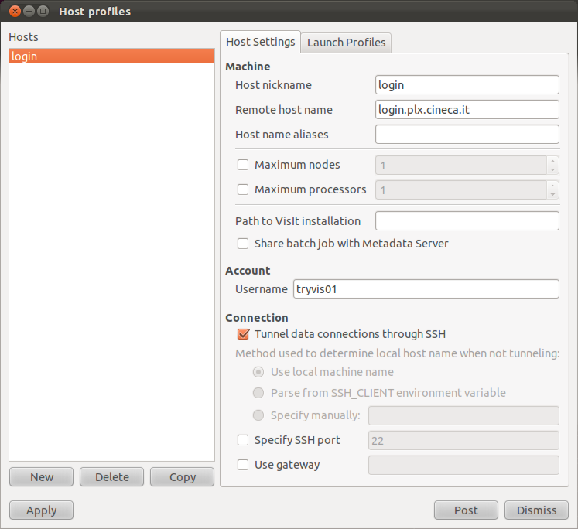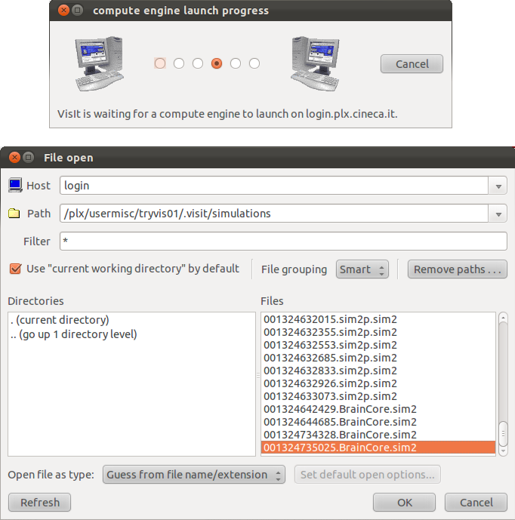
Figure 5. Host profiles, File open and Compute engine launch progress windows.
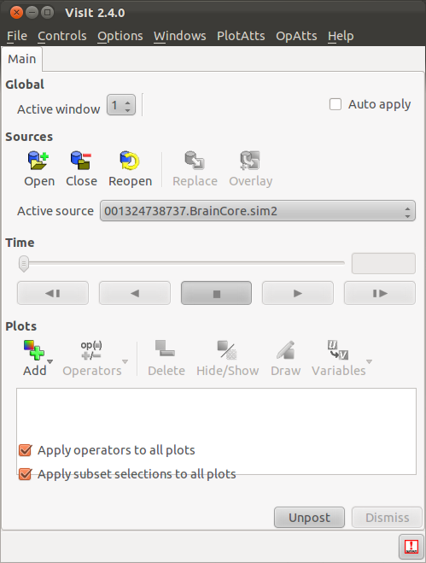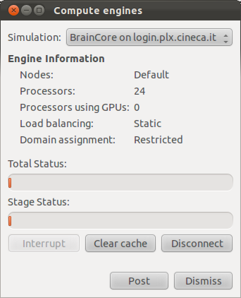
Figure 6. VisIt’s main window and Compute engines window show that a VisIt client is attached to a running BrainCore simulation.

  - Neuron population data visualization

    - Model description
The model of a neocortical patch with neural field visualization was based on a working memory simulation [9]. The simulation replicates a sequential replay of memory items in the cortex during a so-called free recall paradigm where a subject is prompted to recall the previously memorized items. The model is describes a single-region cortical path of the size 4 mm x 4 mm. The hypercolumnar architecture is similar to that described in 2.1.1. The patch consists of 8 x 8 hypercolumns, each containing 49 minicolumns. There are 30 pyramidal (excitatory) cells in each minicolumn and their instantaneous membrane potential is output to the file in ASCII format. Although the simulation step is 0.1 ms, the data is synthesized for every tenth steps, hence the sampling rate of the resulting LFP signals is 1000 Hz.

The long-range connectivity is set up to store 49 non-overlapping memory patterns each comprising 64 equally-selective minicolumns in different hypercolumns. Pyramidal-to-pyramidal connectivity within a minicolumn (short-range) is at the level of 25%. In addition, pyramidal cells are connected to the 8 closest inhibitory cells in their own hypercolumn and remaining connections targeted pyramidal cells in other hypercolumns. The inhibitory cells provide feedback inhibition targeting all the pyramidal neurons within their hypercolumn non-selectively. Connections between pairs of neurons are randomly generated according to the connection densities. The network model is implemented such that it can be scaled to much larger sizes.

The model operates in a parameter regime that allows it to maintain two oscillatory states - a stable non-coding ground state and quasi-stable coding active attractor state. The oscillatory activity in the ground state is the result of high levels of excitatory noise and feedback inhibition, while the oscillations in the attractor states are the result of strong feedback inhibition. Consequently, the network produces alpha/beta (15-20 Hz) oscillations during the non-coding state and faster gamma-like oscillations (above 30 Hz) in the coding state. The original network model [10] has been modified by increasing cellular adaptation so that the coding attractor states have finite lifetime of ~200-300 ms and by adding the mechanism of synaptic augmentation so that recently activated attractors can sequentially reactivate after a short refractory period. In consequence, several attractors (memory items) are sequentially stimulated and then periodically replayed in the simulation (only periodic replay is part of simulation for visualization).

Visualizations are performed for the entire cortical path with signals generated from all 94080 excitatory (pyramidal) cells (N_{cells}=94080) and averaged within each minicolumn every 1 ms over 5-s-long simulation, which amounted to 3136 neural units (minicolumns, n=3136) each producing 5000 time points (N_{t}=5000). These are written out to text files, which are used for the visualizations. Minicolumn positions on a two-dimensional grid, illustrated in Fig. 7, were saved in a separate file. The characteristics of the data set are summarized in Section 2.4 below.
    - Visualization environment
Today the scientists in the field of EEG data acquisition and processing have a rich arsenal of modern techniques for signal processing. Mostly they use different toolboxes in MATLAB. MATLAB possesses excellent visualization tools and lighten significantly simulation process. Despite the considerable efforts in recent years to be enhanced parallel multiple processor/core computations and GPU computations, MATLAB still remains a tool for modeling and simulation of systems with limited amounts of data. That is why we choose another tool for visualization, developed by Lawrence Livermore National Laboratory. VisIt [4] is a free, open source, platform independent, distributed, parallel visualization tool. It uses data defined on two- and three-dimensional structured and unstructured meshes. VisIt’s distributed architecture allows it to explore both the computational power of a large parallel computer and the graphics acceleration hardware of a local workstation.
    - Data organization
The input data are organized in two arrays. The first one describes the geometry of the model, i.e. it contains two-dimensional spatial coordinates of neural units (here: minicolumns). The units are dispersed irregularly on a rectangular grid (Figure 7). The size of this data array is n x 2, where n denotes the number of units.

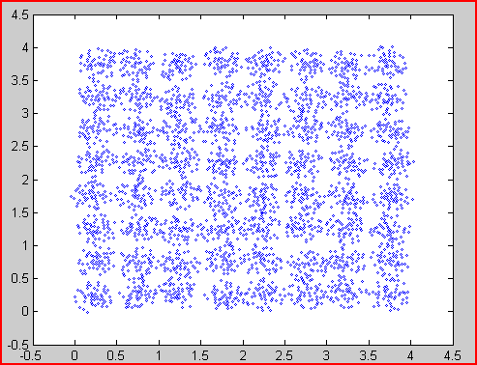

Figure 7. Spatial distribution of data sources (neural units) on a 2D grid. The coordinates are in mm.

The original neural data for visualization is stored in the other array of the size m x 3, where m is the product of the number of simulation time steps, N_{t}, and the number of excitatory cells, N_{cells}. Each row entry contains the cell index, time point (in seconds) and the signal value (magnitude) for visualization. This dataset can be converted to another array, where each row corresponds to the average time series for one neural unit (the mean signal for all excitatory cells belonging to the unit), to enable direct import into the visualization environment. The dimensionality of the resulting array is then n x N_{t}.
    - Data processing
Irregular distribution of neural units is not convenient to be considered. We prefer to have regular mesh, for which non-existent data points to be calculated by interpolation from the existing ones. Several approaches exist. Nearest neighbor interpolation is the simplest one and requires the least processing time. It considers only the closest pixel to the interpolated point. Bilinear interpolation considers the closest four (2x2) of known pixels surrounding the unknown pixel. It then takes a weighted average of these pixels to calculate interpolated value. Bicubic interpolation takes into account the closest 16 (4x4) known pixels, while higher order interpolation applies spline, sinc or other functions for interpolation. These algorithms require considerable more computational resources).

- Results

  - Neuron data visualization

The glyph visualizations of the simulation model nicely provide a visual confirmation that the organization of neurons into mini-columns, hyper-columns and areas is correct. Furthermore, the spreading of activity throughout the network can be verified with the projections and inspected one visualization timestep at a time.

The interactive visualisation of the model in ParaView works well, as the number of neurons isn’t that large in the simulation runs performed so far . The current model can be easily rendered in ParaView on a standard workstation with graphics card. When animating the simulation, visualization timesteps can be displayed fairly quickly in succession.

Using the Xdmf format for data storage worked reasonably well. The only reference to the format is a short document describing the XML structure and a bit of trial-and-error was sometimes needed to get data successfully loaded in ParaView. We unfortunately stumbled upon a number of crasher bugs and other incorrect functionality in ParaView 3.12 during this project, most of which has been reported to the ParaView bug tracker website and hopefully will get fixed in the near future.

Another issue with ParaView is the difficulty of creating a reusable visualization pipeline that can serve as a template for visualizing multiple input datasets. The most attractive way of working with ParaView is to load one or more datasets and interactively piece together a visualization pipeline that produces a satisfactory visualization. In this workflow, changes to the pipeline lead to immediate visual feedback. Once a pipeline is deemed satisfactory one would like to reuse it with different input data, but this proves a bit cumbersome, as changing input data needs to be done manually followed by saving the updated pipeline to a new file. Having a pipeline template in which the input datasets are a parameter would be a much more workable approach. Although Python scripting is available in ParaView for programmatically creating pipelines, this way of working lacks the interactive feedback. A “Python tracing mode” is available that basically records pipeline edits to a Python script, but the resulting scripts didn’t always correctly reproduce the pipelines. Another option, saving a finished pipeline to a Python script, had the same problems.

  - In-situ visualization

We successfully implemented an in-situ visualization approach to a simplified version of BrainCore and demonstrated a simple and convenient way of using this type of visualization in general: from code instrumentation to live data visualization.

After successful connection to a BrainCore simulation running on the PLX Cluster (see 2.2.2), it is possible to investigate data and make plots. By adding a standard VisIt pseudocolor plot and choosing the unit variable the user can see the neural activity in the current simulation time step (Figure 8). Each row of the plot represents one hypercolumn and each cell in the row represents one minicolumn. VisIt’s mesh distribution (result of expression which calls VisIt’s procid function on defined mesh as argument) among processes of running simulation is shown in Figure 9.

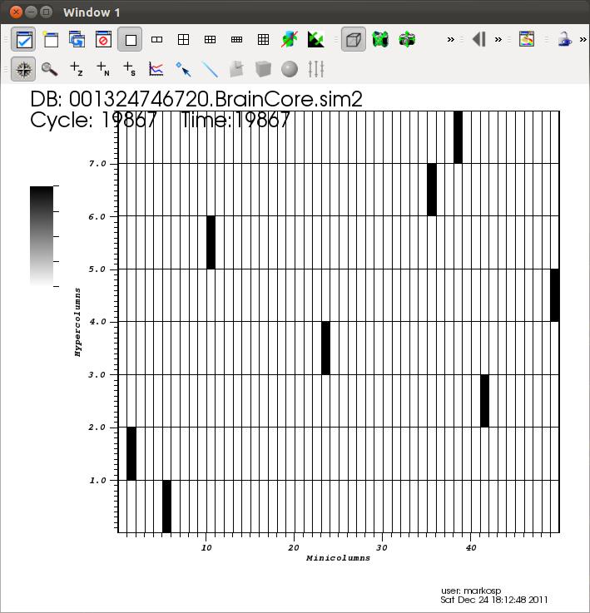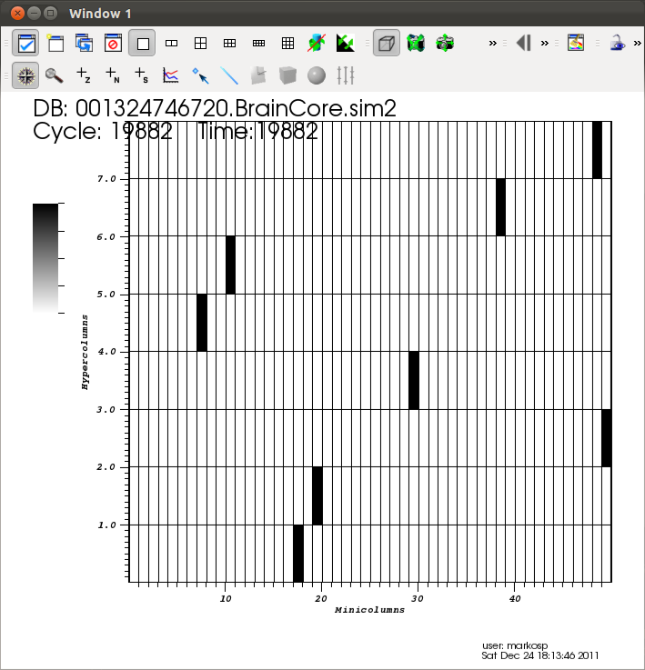
Figure 8. Pseudocolor plot of the unit variable in two different time steps of the simulation. The mesh consists of 8 hypercolumns with 50 minicolumns.
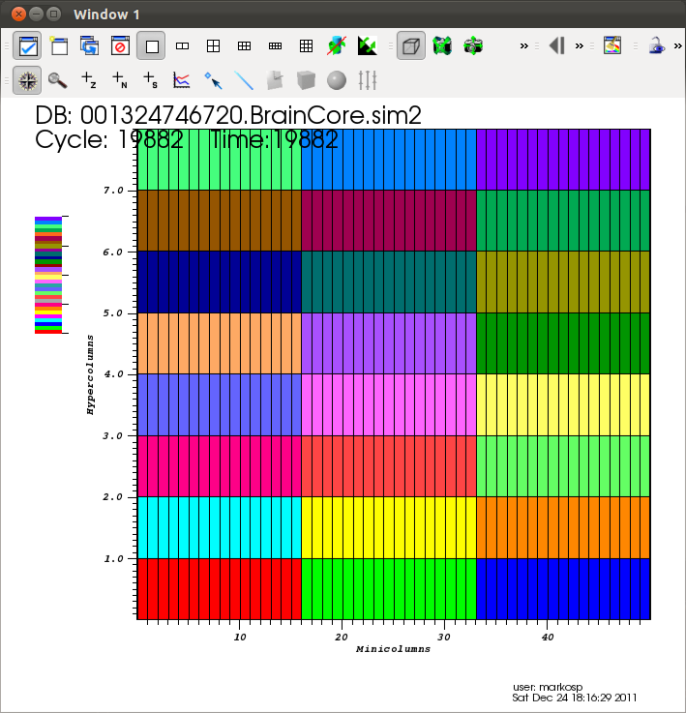
Figure 9. Pseudocolor plot of mesh domains distribution among processes.
By opening the Simulations window, additional information about the attached simulation is provided. It is possible to see different simulations attributes, the simulation status and status of VisIt commands processed by the simulation (now acting as the VisIt compute engine, Figure 10). Simulation steering is provided by the Controls tab and Commands buttons (Halt, Step, Run, Reset, and Update), which perform the following actions:

- Halt – Stops (pauses) execution of the simulation
- Step – Execute one simulation time step
- Run – Continues execution of the simulation
- Update – Redraw current plot
- Reset – Resets the simulation

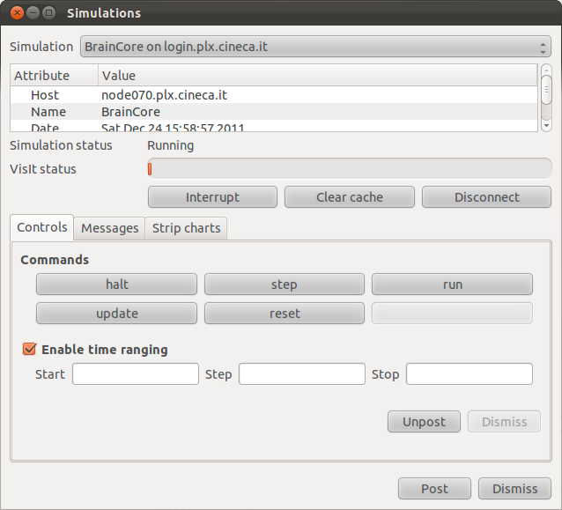
Figure 10. The Simulations window showing commands buttons.
After inspecting the data, the user can detach from the simulation using the disconnect button from the Simulations window or the Compute engines window. After detaching, the simulation will continue its normal execution.

We showed that the user is able to easily connect to the running simulation from any laptop or workstation with internet access and VisIt installed. While connected to BrainCore, the ability to steer the simulation and to visualize live neural activity data was demonstrated. When instrumenting the simulation code we aimed at producing minimal additional code for this purpose and to show the simplicity of using the libsim library. Solid foundations were defined for using this type of visualization for future, more complex network simulations using BrainCore or other neural simulators.

There are some disadvantages in the libsim library that we noticed during the implementation. The libsim is not object-oriented, so it uses handles for representing VisIt objects and function pointers to implement event handlings. Also, the libsim library for the Windows platform is not fully implemented, but VisIt developers have announced that Windows will be supported soon.

  - Neuron population visualization

The results shown here depict VisIt screenshots obtained for the interpolated data (as discussed in 2.3.4). They are shown for an arbitrarily chosen time point. . In our experiments we apply bilinear interpolation (Figure 11). A resampling may be applied to smooth additionally the surface (Figure 12).

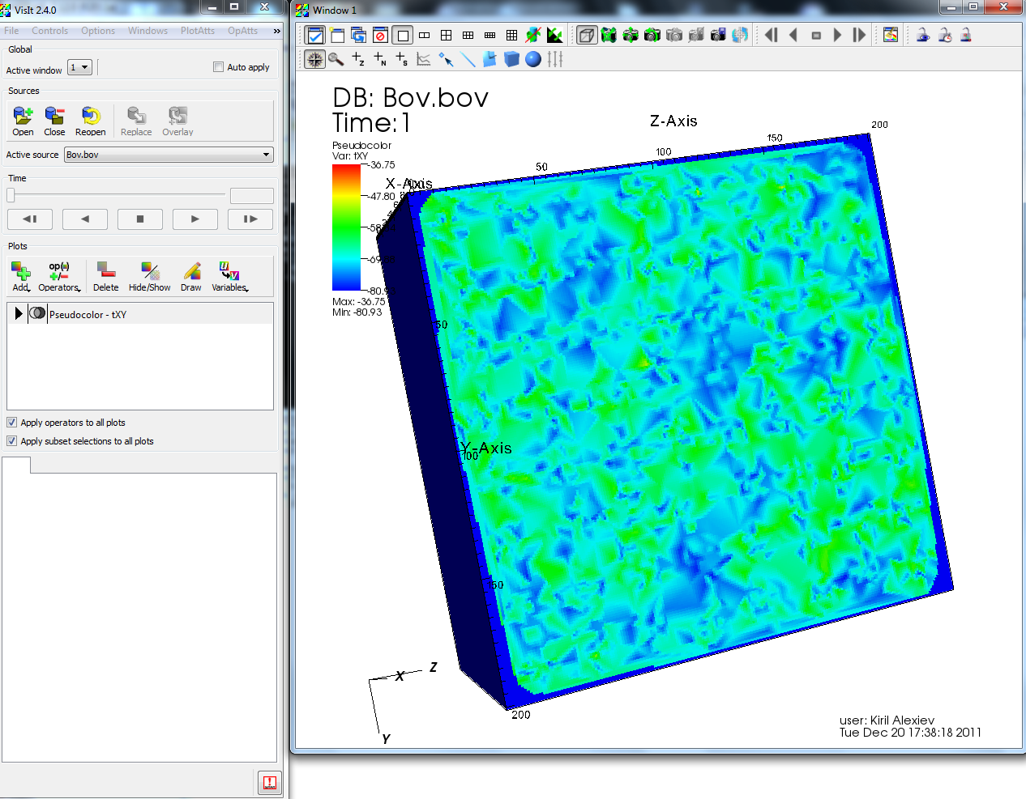 | 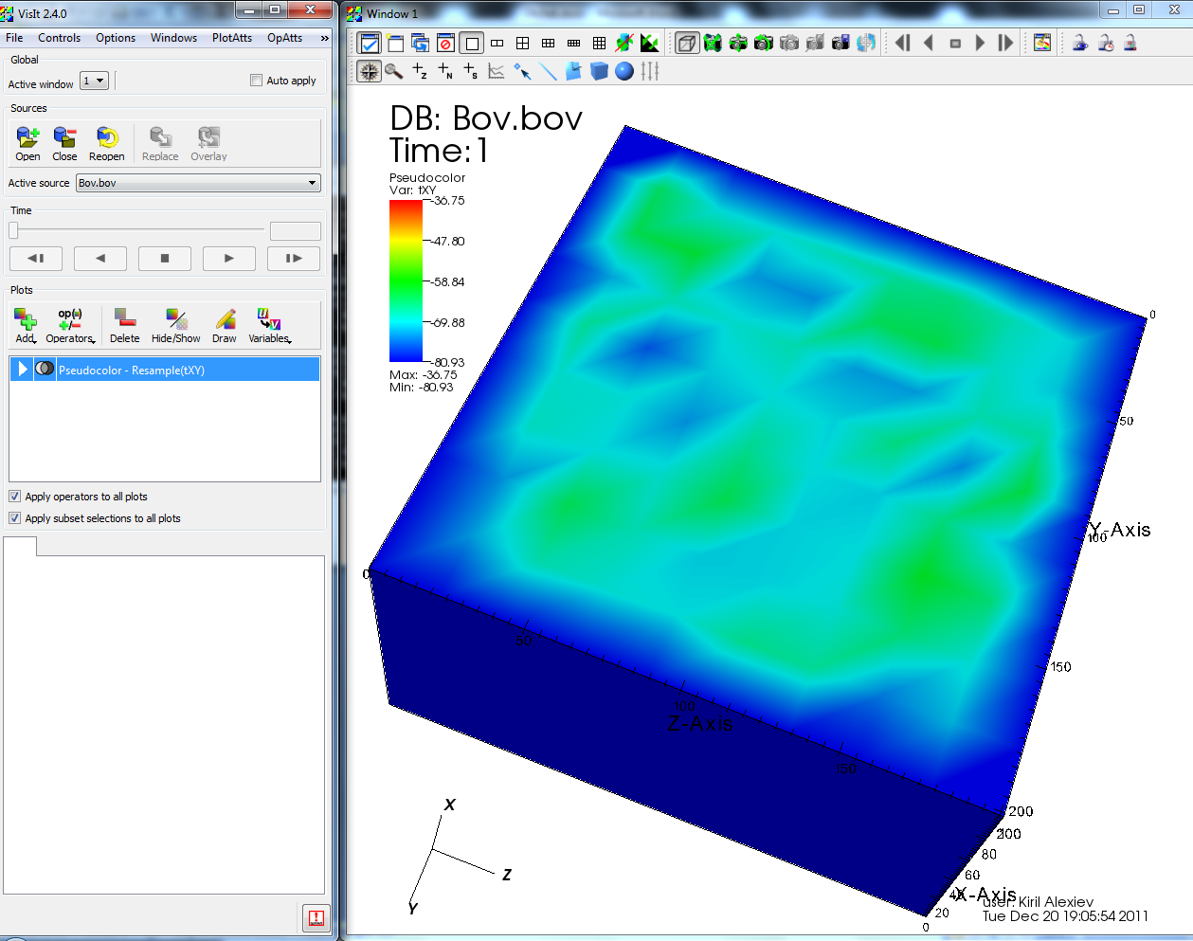
Figure 11. A regular mesh (201x201 points), received by bilinear interpolation. | Figure 12. Smoothing the surface by resampling.

Another screenshot from the movie-like visualization for another time slice with a different colourmap is shown in Fig. 13. The signals can be optionally visualized using a contour plot (Fig. 14).

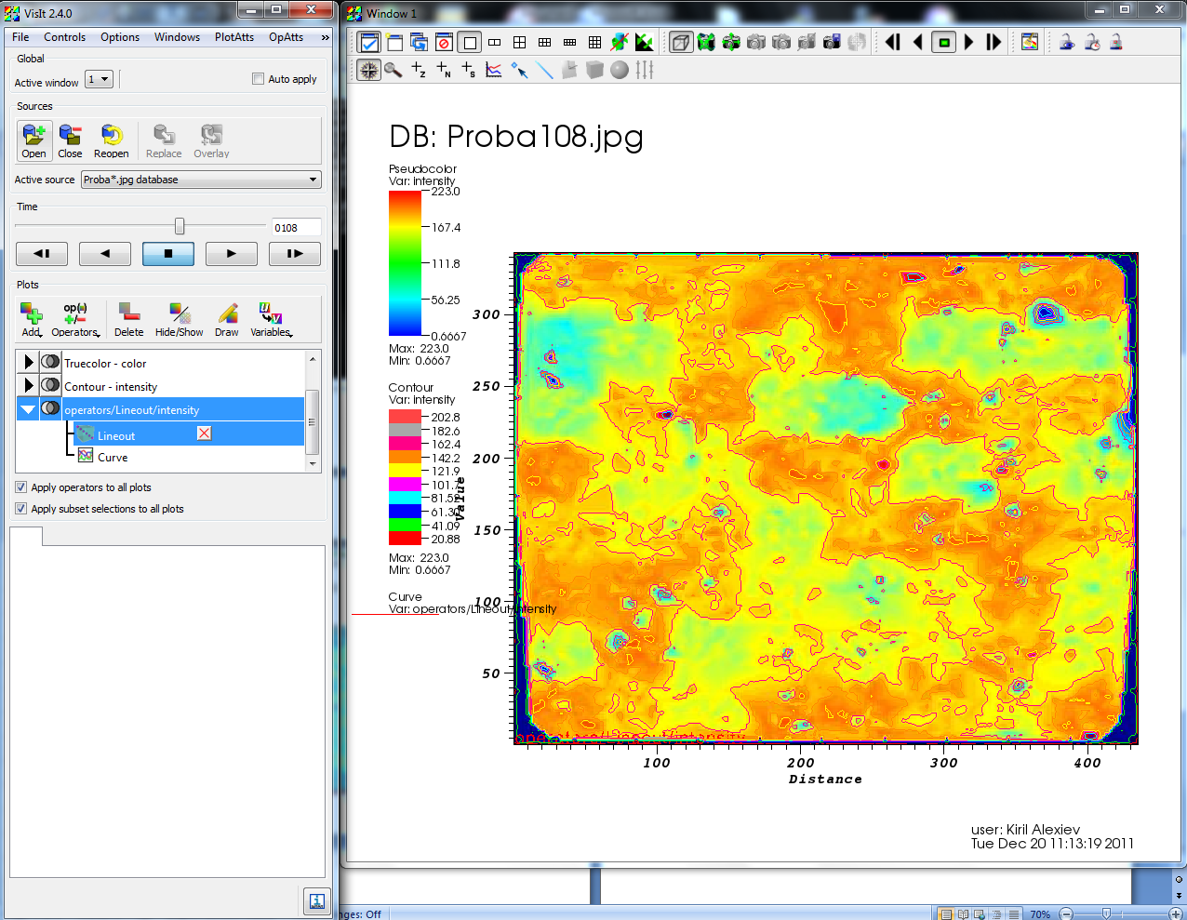 | 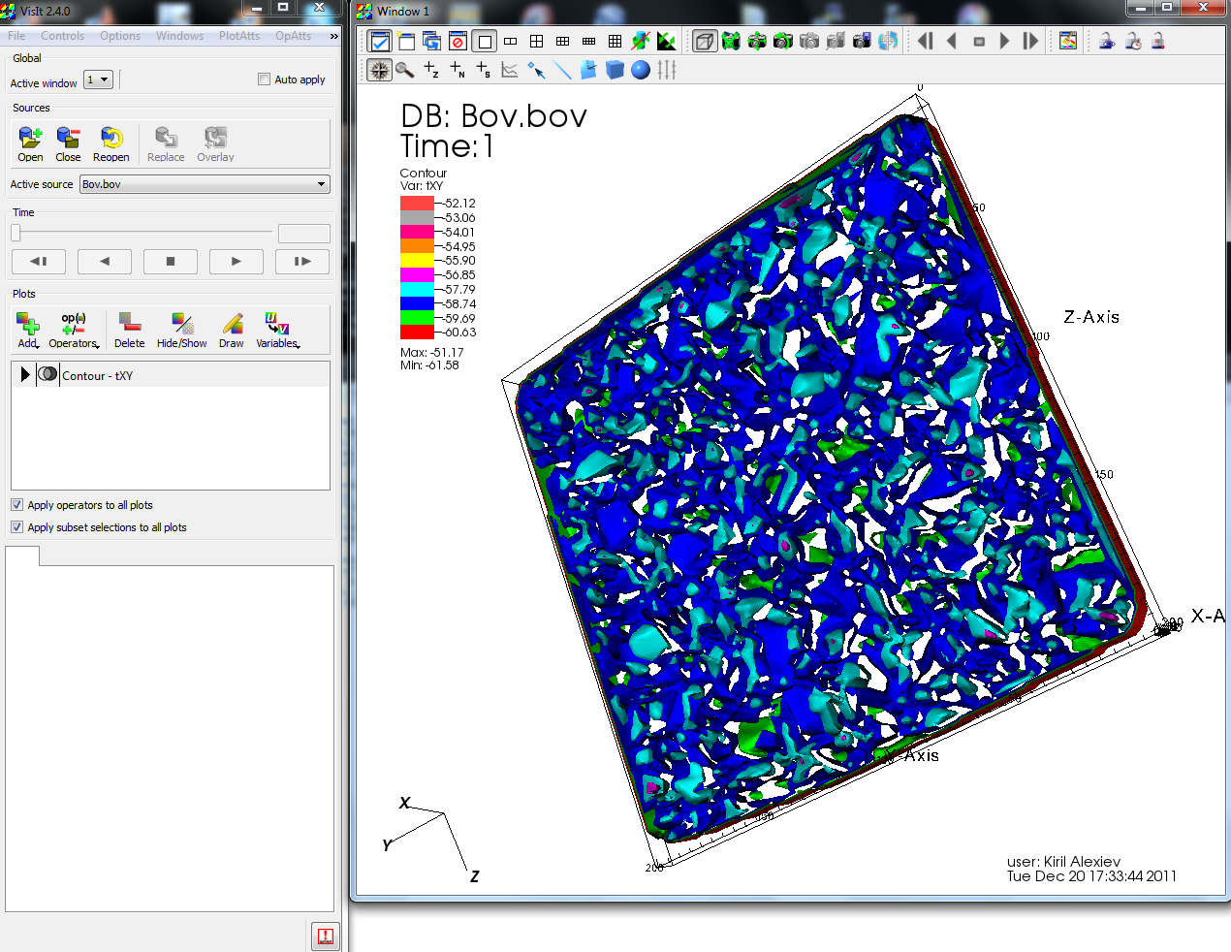
Figure 13. Visualization using another colourmap (one time slice from the movie-like presentation). | Figure 14. Visualization using a contour plot.

- Conclusions
Considering the limited time available for this work quite good results were achieved, which will form the basis for further work in the future. We were able to develop a workflow for visualization of network activity of a brain region at both the single neuron and neuronal population levels, together with realtime visualization of simulated network activity. The open source program package VisIt could be used for in-situ visualization and visualization of synthetic cell mesh activity. The tools developed could potentially be of use for researchers to visualize simulations by providing specific files and parameter settings as needed.
One important remaining issue for future work is to test the scalability of the visualization tools developed. The simulation model currently visualized has a relatively modest number of neurons, around 50,000 – 100,000, though during the course of this project we performed simulations with up to 57 million neurons connected by 7 billion synapses. Since the work started from scratch we developed the applications based on HPC enabled components, but time was not enough for extensive tests of scalability. Larger models will be used in the near future, having on the order of 100,000s neurons. For visualizing output from these models the visualization pipelines developed here can in principle be reused, but the larger scale will negatively influence the 3D rendering and data processing capabilities of ParaView. The VisIt package already allows visualization of large scale system. Its parallel scalability is excellent, especially in the case of multiprocessor/multicore usage and GPU Tesla.
For handling larger models ParaView provides a parallel rendering mode, allowing distributed rendering over multiple rendering nodes, taking advantage of multi-core and multi-GPU hardware. Changes to the HDF5-based data layout might be necessary for this mode, to split up the per-timestep files into several standalone pieces that can be individually read by the render nodes, as this is the way ParaView can most efficiently read in the data in parallel.
Furthermore, the mapping onto the whole brain model can be improved and the visualization of connectivity at the micro- and macroscopic level, including visualization of impulse propagation could be added. But even as it stands now, this preparatory project has provided useful tools to be incorporated in our brain simulation toolkit.

Acknowledgements
This work was financially supported by the PRACE project funded in part by the EUs 7th Framework Programme (FP7/2007-2013) under grant agreement no. RI-211528 and FP7-261557. The work is achieved using the PRACE Research Infrastructure resources [PARADOX, IPB, Serbia and PLX, CINECA, Italy].
References
- A. Squillacote, The ParaView Guide, A Parallel Visualization Application.Kitware Inc., 2008.
- Silverstein, D. and Lansner, A. (2011). Is attentional blink a byproduct of neocortical attractors? Front Comput Neurosci, 5, 1-14. Retrieved from 10.3389/fncom.2011.00013
- eXtensible Data Model and Format, http://www.xdmf.org/index.php/Main_Page
- VisIt Visualization Tool, https://wci.llnl.gov/codes/visit/
- Parallel Visualization For Very Large Data Simulations, ftp://ftp.cscs.ch/out/jfavre/ParallelVisualizationForVeryLargeDataSimulations.pdf
- Brad Whitlock, Getting Data Into VisIt,
https://wci.llnl.gov/codes/visit/2.0.0/GettingDataIntoVisIt2.0.0.pdf, 2010
- Benjaminsson, S. and Lansner, A. (2011). Extreme Scaling of Brain Simulations. In Jülich Blue Gene/P Extreme Scaling Workshop 2011, Mohr, B. and Fring, W. (Eds.), Technical Report FZJ-JSC-IB-2011-02, Forschungszentrum Jülich.
- IBM-PLX User Guide, https://hpc.cineca.it/content/ibm-plx-user-guide
- Lundqvist, M., Herman, P. and Lansner, A. (2011). Theta and gamma power increases and alpha/beta power decreases with memory load in an attractor network model. J. Cogn. Neurosci. 10, 3008-3020.
- Lundqvist, M., Compte, A. and Lansner, A. (2010). Bistable, Irregular Firing and Population Oscillations in a Modular Attractor Memory Network. PLoS Comput. Biol. 6, e1000803.

Corresponding author. E-mail address: ala@kth.se.

